South Yorkshire Orienteers
affiliated to Yorkshire and Humberside Orienteering Association

Level C Event Sunday 15th December 2013

Canklow Woods, Rotherham

Assembly  and Car Park | Car parking is within the grounds of Thomas Rotherham College which is just off the M1 Motorway to the south of Rotherham. Registration and download is inside the college next to the car park.  Thomas Rotherham College is located at the junction of Moorgate Road and Boston Castle Grove, Rotherham. . Post code S60 2BE | . 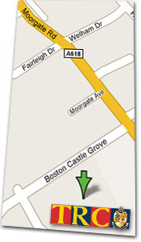
Travel | The event will be signed from the from the M1 junction 33.  Head NE on the A 630 for 0.4 miles. At the roundabout take the 2nd exit onto the A631 Bawtry Road for 0.8 miles. Turn left at A618 Moorgate Road. In 1.2 miles turn left into Boston Castle Grove.
Terrain | Canklow is a steep wooded area with many paths and intricate detail at the top. It is an area used by local people for walking dogs etc. There are also occasional motorcycle riders in the woods.
Map | 1:7500 ISOM
Courses | Colour Coded courses. (White, Yellow, Orange, Light green, Green, Blue and Brown).  The White is unsuitable for pushchairs
Starts | 1030am to 1230pm  The Start and Finish are 5 mins away from Registration
Entry | On the day.  SI punching will be used  Fees Seniors £8 (BOF members £6) Juniors and concessions £3
Dogs | Dogs welcome under control in the woods but please keep on a lead in the  college grounds and clear any mess up
Organiser - Colin Best (colinallanbATyahoo.co.uk) Tel 0114 2302 621
Planner - Chas Hird

Controller - Clive Wilson

